Mukesh Choudhary  P.NO-2,Shyamnagar Vistar,Benad Road  Jhotawara,Jaipur  Mob: 9929948207  E-Mail: mukeshmavaliya@gmail.com | 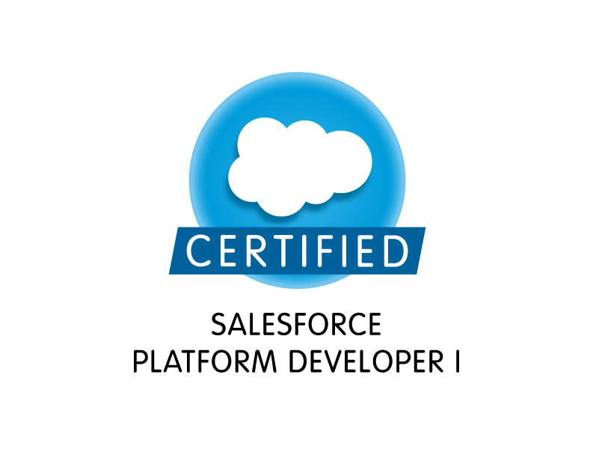

Professional Synopsis

- A competent professional with 6.7 years of IT industry experience in Software Development & Programming.
- Certification in Microsoft Sql Server 2008, Database Development.
- Versatile knowledge Consultants Pvt Ltd, as a Team Leader from 21 July 2013 to till date.
- VertexPlus Softwares Pvt. Ltd. as a Team Leader from Apr 2012 to Jul 2013
- Neutrino IT Technologies Pvt. Ltd as a Software Developer from Nov 2009 to Mar 2012
- Experience in developing Apex trigger, Validation Rule, Workflow Approval , SOAP API, REST API, Web Service ,Payment Gateway Integration C#.Net, ASP.Net, Ado.Net, SQL Server (2000, 2005, and 2008), JavaScript applications.
- Possess strong programming and problem solving skills.
- Adept in end-to-end development of embedded software products from requirement analysis to designing, coding testing, de- bugging, documentation and implementation.
Professional Qualification

- MCA (SMU).
- B. Sc(Rajasthan University)
- GNIIT From NIIT, Jaipur

Computer Skills
Language : Visual force, Apex ,C#.Net, Ado.Net.
Platform : Salesforce , ASP.Net 2.0,3.5,4.0
Databases : SQL Server (2000, 2005, 2008).
Operating System : Windows XP, Windows 7
Web Server : IIS, ASP.Net Development Server.
Scripting Language : JavaScript, JQuery .
Other : Apex trigger, Validation Rule, Workflow approval , SOAP API, REST
API, web service ,Shopping Card Integration, Payment Gateway
Integration(PayPal, EBS, Stripe) ,Email Integration (Mandrill) , SOSL, SOQL
Project Details:

- UberConference Outlook Add-In
  - Project Objective – This is a window application. Using this application user scheduled meeting in uberConference with outlook. Using this application user insert, update and delete meetings from uberconference.
  - Role – Team Lead, (Versatile knowledge Consultants Pvt Ltd)
  - Key Responsibilities- Design application, Coding, Testing
  - Team Size- 2 members
  - Technologies Used- C#, .net, VS 2010, Outlook 2007, 2010, 2013 ,Add-In Express, DevExpress, UberConference Api .

- Hello Meeting
  - Project Objective – These application schedules meeting with lead and company members. Using cronofy api get user free busy schedule with google calendar and meeting accordingly. After meeting successfully completed application send gift card to lead.
  - Role – Team Lead, (Versatile knowledge Consultants Pvt Ltd)
  - Key Responsibilities- Create object, Trigger ,Apex Classes ,Batch Classes
  - Team Size- 5 members
  - Technologies Used- Apex , SOQL, Visual force,salesforce lighting ,cronofy api (calendar api) ,JQuery ,Java Script.

- Bria Force
  - Project Objective - Authorization with stretto application. Create user in stretto application. Setup call center and log a incoming and outgoing call data in to salesforce.
  - Role – Team Lead, (Versatile knowledge Consultants Pvt Ltd)
  - Key Responsibilities- Create object, Trigger ,Apex Classes ,Batch Classes
  - Team Size- 3 members
  - Technologies Used- Apex, SOQL, Visual force, Bootstrap, stretto services, JQuery ,Java Script.

- UberConference Force
  - Project Objective - Authorization with UberConference using OAuth 2.0. Schedule meeting and create contact in UberConference using Lead ,Contact ,user and event from salesforce.
  - Role – Team Lead, (Versatile knowledge Consultants Pvt Ltd)
  - Key Responsibilities- Create object, Trigger ,REST API Classes ,Batch Classes
  - Team Size- 2 members
  - Technologies Used- Apex , SOQL, Visual force, Bootstrap, UberConference Api ,JQuery ,Java Script.

- Email Force
  - Project Objective- Sent email from Contacts and lead with salesforce native functionality .sent auto email from campaign and campaign member using mandrill email API services.
  - Role – Team Lead, (Versatile knowledge Consultants Pvt Ltd)
  - Key Responsibilities- Create object, trigger ,REST API classes ,Batch classes
  - Team Size- 2 members
  - Technologies Used- Apex ,SOQL, Visual Force, Bootstrap, Mandrill API, JQuery ,Java Script.

- Payment Force
  - Project Objective - Payment runs/payment batch process should be used to collect payments for a batch of customers. We will provide the capability to create an ad hoc (on demand) payment run that executes once, or user can create a scheduled payment run to execute on a recurring basis (daily, monthly, etc.). Only accounts with the Auto-Pay option enabled (cannot enable auto-pay if the customer does not have valid billing Info) and which have a due invoice/payment-schedule/opportunity should be processed in a payment run
  - Role – Team Lead, (Versatile knowledge Consultants Pvt Ltd)
  - Key Responsibilities- Create Object, Trigger ,REST API, Classes ,Batch Classes
  - Team Size- 3 members
  - Technologies Used- Apex ,SOQL, Visual Force, Bootstrap , Stripe API, JQuery ,Java Script.

- Media Force
  - Project Objective- Media Hub is an end-to-end platform that integrates and coordinates the ad selling process across the many different departments, roles, and systems involved with selling, delivering, billing, planning, and tracking advertising. The Versatile Media Hub platform contains a set of modules to address the needs of different users in this process.
  - Role – Team Lead, (Versatile knowledge Consultants Pvt Ltd)
  - Key Responsibilities- Create Object, Trigger ,WSDL Classes, Batch classes
  - Team Size- 3 members
  - Technologies Used- Apex , SOQL, Visual Force, Bootstrap, JQuery ,Java Script.

- E-commerce websites
  - Key Responsibilities - Database Design, Coding, Testing ,Shopping Card Integration, Payment Gateway Integration.
  - Role – Team Lead, (VertexPlus Softwares Pvt. Ltd.)
  - Team Size- 3 members
  - Technologies Used- .Net Framework 4.0, Asp.net with C#, SQL server 2008, Ajax, JQuery ,Java Script.

- Hotel Booking Engine
  - Project Objective - Booking Engine for hotels is a feature packed tool that allows you to take direct bookings through your own website . Hotel site will work alone with online hotel reservation software, converting the visits into bookings and generating higher revenues per booking. User able to set day to day room price.
  - Key Responsibilities- Database Design, Coding, Testing , Payment Gateway Integration.
  - Role – Team Lead, (VertexPlus Softwares Pvt. Ltd.)
  - Team Size- 2 members
  - Technologies Used- .Net Framework 4.0, Asp.net with C#, SQL server 2008, Ajax, JQuery ,Java Script.

- UNIERP – Complete ERP module for a University, for atomization of all departments. There all 24 different module in this project which include all the major aspects of any university or college like academics, library, Fees, Time Table, Attendance, Transportation, Exams, Result, Hostel, Mess, Inventory etc...
  - Project Objective-The main objective of this project to cover all departments of a university to be atomized and make a system that completely remove the paper work from university.
  - Role – Developer, (Neutrino IT Technologies Pvt. Ltd)
  - Team Size-Total 12 peoples working in this module (10 developers , 2 system tester )
  - Modules Undertaken-Academics, Library, Student, Faculty.
  - Key Responsibilities-Direct meeting with Accounts department to understand their requirements, develop system (include coding, database designing, unit testing ), implement the system on server and check the system on client end also .(example library , fees departments, academic departments)
  - Technologies Used- .Net Framework 3.5, Asp.net with C#, SQL server 2005, Ajax, Intranet based application.

- RNIS Clinical College – It is a dynamic website. it has four modules of users admin, Faculty, Student and Staff. Administrator has all rights like post, approve, and disapprove programs, course, department, news, notices, events, and seminars. Administrator can manage all contents of website. Faculty, students and staff can update and view their profile.
  - Client- Ritu Nanda Group of Institutions, http://www.rnisclinical.org/
  - Role – Developer, (Neutrino IT Technologies Pvt. Ltd)
  - Team Size- 3 members
  - Technology used-ASP.NET 3.5, SQL Server 2005, Ajax and Java Script

- Inventory Management System – It is used for offline access to data. It transfers the local database into online server database when plug to internet on a single click. In this project admin can create stores and transfers the stock according to store requirement.
  - Key Responsibilities – Analysis cum Design of project. And implement Database synchronization using Microsoft Synchronization framework and web services.
  - Role – Developer, (Neutrino IT Technologies Pvt. Ltd)
  - Client- Muskan Bioagrotech Pvt Ltd., http://neutrino.in/MuskanERP/
  - Team Size-4 members
  - Technology used-ASP.NET 3.5, SQL Server 2008,SQL Server compact edition, Microsoft Sync Framework, Ajax and Java Script

- Rajasthan Police Web Portal –Rajasthan Police web Portal is a web-enabled end to end integrated solution to make transparency in all police departments.
  - Key Responsibilities – implement localization, globalization and membership
  - Role – Developer, (Neutrino IT Technologies Pvt. Ltd)
  - Client- Raj comp Info Services., http://police.rajasthan.gov.in/
  - Team Size-6 members
  - Technology used-ASP.NET 3.5, SQL Server 2005, Ajax and Java Script

- LNMIIT Admission Portal –Complete online admission portal. Web application developed for UG and PG admissions. Students can apply for B Tech, M Tech, MS and PhD admission online.
  - Client- Lakshmi Niwas Mittal Institute of Information Technology, http://lnmiit.ac.in/
  - Role – Developer, (Neutrino IT Technologies Pvt. Ltd)
  - Team Size- 6 members
  - Technology used-ASP.NET 3.5, SQL Server 2005, Ajax and Java Script

- Jaipur National University- it is a dynamic website for JNU which have complete SAAS solution for university. The major modules are admin, Faculty, Student and Staff. Administrator has all rights like post, approve, and disapprove programs, course, department, news, notices, events, and seminars. Administrator can manage all contents of website. Faculty, students and staff can update and view their profile.
  - Client- Jaipur National University, http://neutrino.in/jnu/
  - Role – Developer, (Neutrino IT Technologies Pvt. Ltd)
  - Team Size- 3 members
  - Technology used-ASP.NET 3.5, SQL Server 2005, Ajax and Java Script

Strength
- Willingness to walk the extra miles to achieve the excellence.
- Honesty, sincerity and faith in God.
- Ability to deal with people.
- Optimistic attitude and will power.

Personal Details
Father name : Shri Biradi Chand Choudhary
Date of Birth : 1 April 1986
Gender : Male
Languages : English, Hindi
Hobbies : Reading Books, Browsing net, soft music

I hereby declare the Authenticity of above for mentioned facts and can produce testimonials whenever asked for
Date: -
Place: - (Mukesh Choudhary)

